**.git folder:**

The .git folder contains all the information that is necessary for your project in version control and all the information about commits, remote repository address, etc. All of them are present in this folder. It also contains a log that stores your commit history so that you can roll back to history.

* Hooks
* Info
* Objects
* Config
* Description
* HEAD

Above are the folders that present in .git folder.

**Hooks:**

This folder has a few script files inside it. These script files are known as Git Hook Scripts. Git hooks are the scripts that are executed before or after the events. These events can be any Git event including the common Git events like commit, push or receive. These scripts increase the productivity of the developer.

A pre-commit script is the one which is executed before executing the commit event. This may include checking the spelling errors etc. Similarly, a post-commit script is executed after the commit is done. You can enter the hooks folder to see the different scripts in it with the pre-commit script that we just talked about. You can change these scripts or update them according to you.

**Info:**

Info folder contains the exclude file inside it. As the name suggests, exclude file is used for excluding some specific patterns in the code that you don’t want Git to read or execute as to say. Remember that this file is local and personal to you and is not shared among the developers that clone your project. If there is something that should be ignored by all of the developers in the project, then that comes under the .gitignore about which we will talk in the later tutorials.

**Objects:**

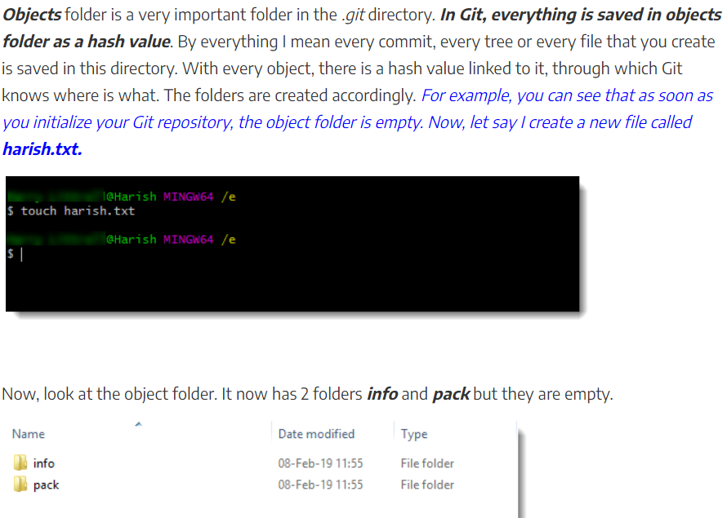

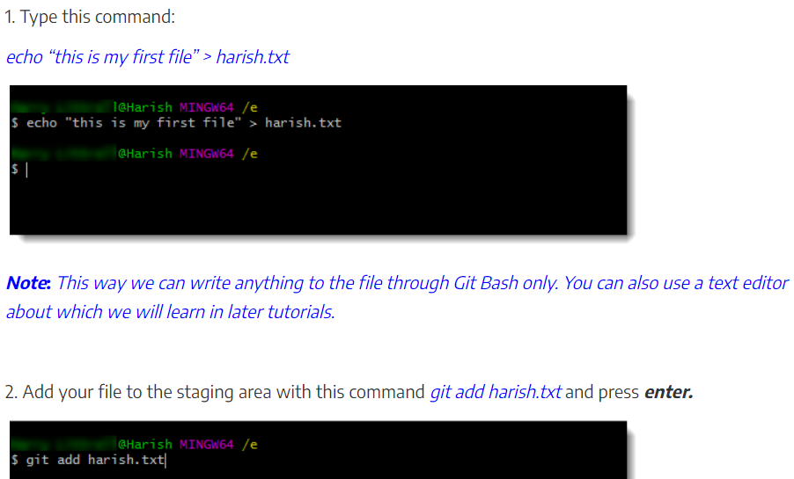

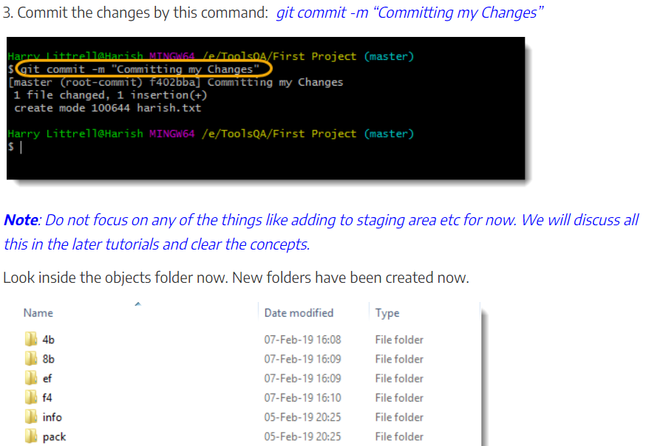

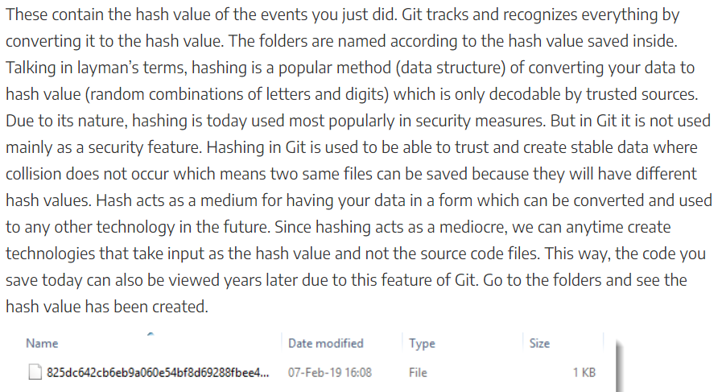

**Config:**

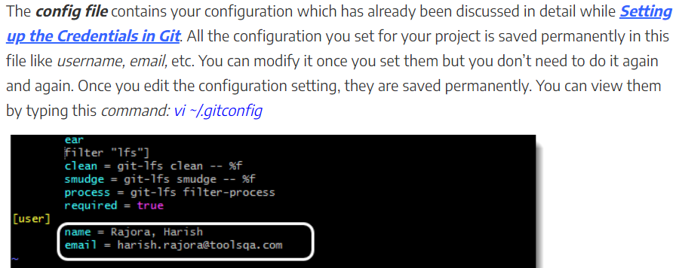

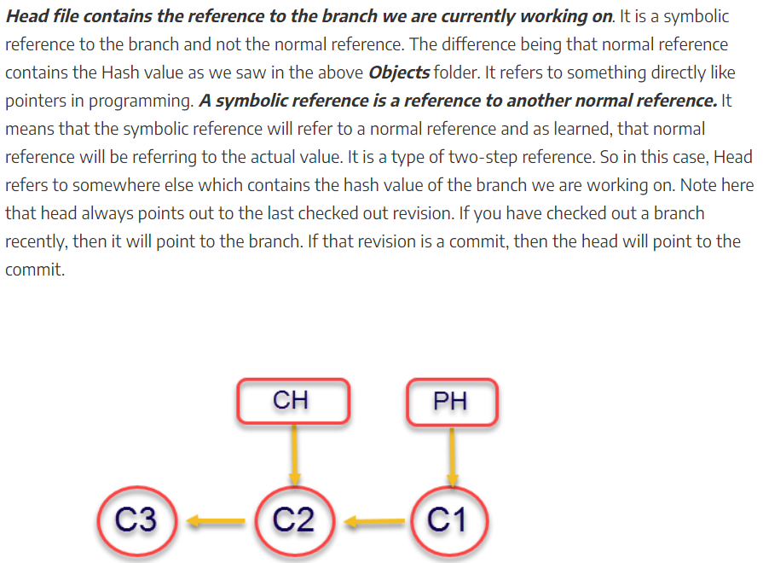

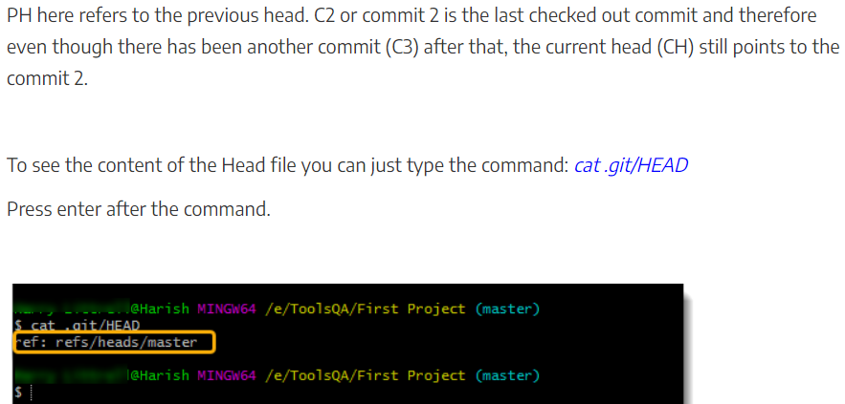

**Deleting .git folder:**

